**Audit Logging using Hibernate envers**

1. Add the following dependency to the existing Project Spring web starter project

<dependency>

<groupId>org.hibernate</groupId>

<artifactId>hibernate-envers</artifactId>

</dependency>

1. Add the following property in application.properties file to store the audit log information in a separate schema

spring.jpa.properties.org.hibernate.envers.default_schema=kish_audit

1. Add the following property in application.properties file to store the audit log information if when the entity is deleted

spring.jpa.properties.org.hibernate.envers.store_data_at_delete=true

1. Add the following annotations to entity class to store the audit log information if when the entity is created/Updated/deleted

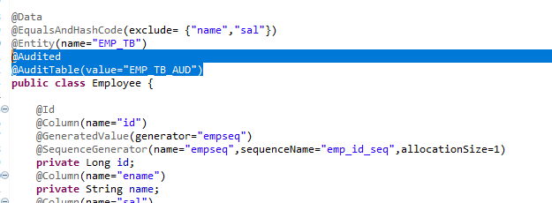

1. System stores the audit information in corresponding audit log table

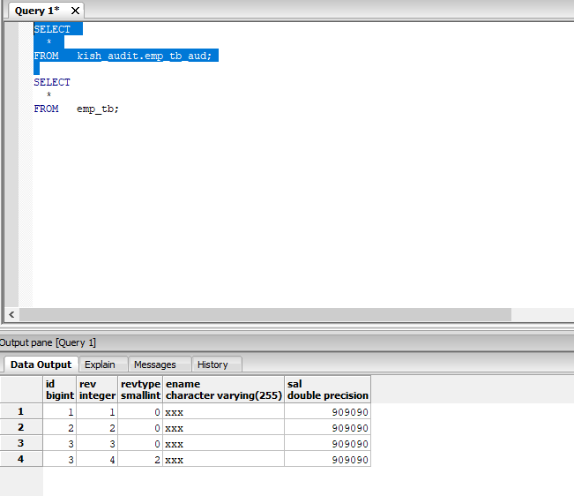

1. In the column rev holds Name of a field in the audit entity that will hold the revision number

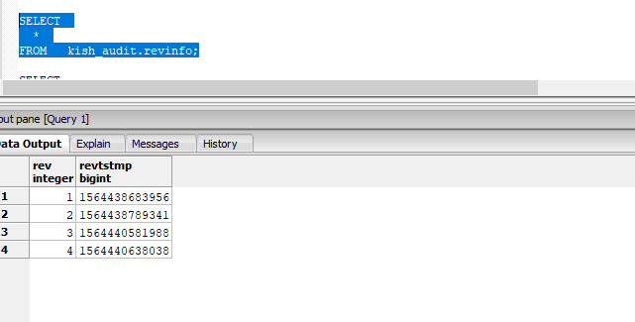

1. Column revtype in the audit entity that will hold the type of the revision

0🡪add,

1🡪update

2🡪 del